WorldPop/NPC/GRID3 Nigeria Workshop on Modelled Population Estimates to Support Census in Nigeria

**Dates:** February 6th to 14th February 2023

**Location:** Abuja, Nigeria

**Participants:** GRID3/WorldPop, NPC

**Background:**

The last National Population and Housing Census for Nigeria was conducted since 17 years ago in 2006, and the National Population Commission (NPC) is nearly all set to conduct the next census in April 2023. However, to better plan for the exercises in terms of logistics and resource allocation, GRID3/WorldPop at the University of Southampton, a global leader in developing bespoke statistical methods for modelled population estimates is working in partnership with the NPC to provide technical assistance and training to the NPC staff beginning with a 5-Day workshop on modelled population estimates holding in Abuja from 6th to 10th February 2023.

**Workshop Aims**: The overarching aim of the 5-Day in-person workshop is to build the capacity of the NPC staff to learn how to develop and implement statistical methods for modelled population estimates to support census preparations. In collaboration with the NPC there will be discussions around population data needs of Nigeria, model potential input data availability and accessibility, and how to co-design and co-develop the Nigerian context-specific robust population model.

**Specific Objectives:**

* Training of NPC staff on methods and implementation of modelled population estimates
* Technical assistance on the development of model-based statistical methods for producing high-resolution population estimates.
* To foster collaborative atmosphere to co-design and co-develop high-resolution population estimates based on previous censuses, surveys, administrative and ancillary sources, including geospatial and remote sensing tools.
* To have a clearer picture of how to collaborate in co-designing and co-developing a robust Nigerian population estimation model.

At the end of the 5-Day workshop, it is hoped that there would be a better understanding of Nigeria situation, data availability, potential challenges, and their mitigation measures, and the ‘best’ candidate Nigerian context-specific statistical population models. Finally, findings from the workshop may be used to inform the design and implementation of the hybrid census, and the estimates of population that would be produced from the bespoke models would form a crucial part of the validation tool for the population dynamics of the Census.

**Draft Agenda**:

|  |  |  |  |
| --- | --- | --- | --- |
| **Day 1 – Monday 6th of February**  **Objective: Overview and Introductions** | | | |
| **Time** | **Sessions** | **Facilitation/Presenter** | |
| 9.00-9.15 | Opening remarks and introductions | GRID3/WorldPop | |
| 9.15-9.45 | **Overview of Nigerian population/census situation** | Representatives from NPC | |
| 9.45 – 10.15 | Overview of WorldPop | Chris/Sarchil | |
| 10.15 – 10.30 | Break |  | |
| 10.30 - 12.00 | Overview of WorldPop top-down and bottom-up population models | WorldPop - Chris | |
| 12.00 - 13.00 | Lunch |  | |
| 13.0– 14.30 | Basics of R – Theory/Practical | Ortis | |
| 14.30-14.40 | Break |  | |
| 14.40 – 16.00 | Key functions in R - Practical | Ortis | |
| 16.00 – 16.30 | Group Activities/IT support/Wrap-Up | All | |
| **Day 2 – Tuesday 7th of February**  **Objective: General Overview of (Bayesian Statistical) Regression Modelling** | | | |
| **Time** | **Sessions** | **Facilitation/Presenter** | |
| 9.30-9.45 | Summary and a brief reflection on Day 1 Activities | All | |
| 9.45 - 10.30 | Basics of regression analysis: background, model specification (simple and multiple) | Chris | |
| 10.30 - 11.00 | Exercise & Group Activities | All | |
| 11.00 - 11.10 | Break |  | |
| 11.10 – 12.00 | Probability & Bayesian Statistics | Chris | |
| 12.00 – 13.00 | Lunch |  | |
| 13.00– 13.30 | Overview of Bayesian Statistical Modelling/Hierarchical Regression Modelling | Chris | |
| 13.30 - 14.30 | Practical -Fitting Bayesian Statistical Models in R (INLA/STAN) | Chris | |
| 14.30 – 14.40 | Break |  | |
| 14.40 - 16.10 | Exercise & Group Activities | Chris | |
| 16.10 - 16.30 | Wrap/Discussions/Announcements | All | |
| **Day 3 – Wednesday 8th of February**  **Objective: Understanding the development and implementation of population models techniques in STAN** | | |
| **Time** | **Sessions** | **Facilitation/Presenter** |
| 9.30- 9.45 | Summary and brief discussion for day2 |  |
| 9.45 - 10.50 | Basic Bottom-up population modelling with STAN – Practical/Real data example | Chris |
| 10.50 - 11.00 | Break |  |
| 11.00 - 12.00 | Exercises/Group Activities | Chris |
| 12.00 -13.00 | Lunch |  |
| 13.00 – 14.30 | Modelling large scale spatial variation in population data in (R STAN) - Practical | Chris |
| 14.30 – 14.40 | Break |  |
| 14.40 - 15.30 | Nigerian population data situation/needs/population modelling needs | NPC |
| 15.30 – 16.20 | Manipulating spatial data in R(GIS in R) - Practical | Ortis |
| 16.20 - 16.30 | Wrap Up/Announcements |  |
| **Day 4**  **Objective: More Bottom-Up Population Modelling Techniques** | | |
| **Time** | **Sessions** | **Facilitation/Presenter** |
| 9.30-9.45 | Summary and a brief reflection on Day 3 | All |
| 9.45-11:00 | Modelling small scale spatial variation in population data | Chris |
| 11.00 -11.15 | Break |  |
| 11.15 -12.00 | Exercises/Group Activities/Discussions | All |
| 12.00 – 13.00 | Lunch |  |
| 13.00 -14.30 | Population model fit diagnostic/Cross-Validation/MCMC chains convergence checks | Chris |
| 14.30 – 14.40 | Break |  |
| 14.40 – 16.20 | Exercises/Group Activities/Discussions | All |
| 16.20 - 16.30 | Wrap up/Announcements |  |
| |  | | --- | | **Day 5 – Friday 10th February**  **Objective: Advanced Population Modelling and Geospatial Covariates** | | | |
| 9.30-9.45 | Summary and reflections on Day 4 | All |
| 9.45-11.00 | Making predictions with population models – Real data practical in R STAN | Chris |
| 11.00 - 11.10 | Break |  |
| 11.10 -12.00 | Implementing Bottom-Up population models in R INLA/Applications | Chris/Ortis |
| 12.00 -13.00 | Lunch |  |
| 13.30 - 14.30 | Exercises/Group Activities |  |
| 14.30-16.20 | Discussions on potential model designs/ input data/covariates/challenges/timelines | NPC, WorldPop |
| 16.20-16.30 | Closing and discussions on follow-up support | NPC/WorldPop |

**Workshop Requirements for the participants –** Please see the pre-workshop information document.

**Background reading**

* The Value of Modelled Population Estimates for Census Planning and Preparation: <https://www.unfpa.org/resources/value-modelled-population-estimates-census-planning-and-preparation>
* Spatially disaggregated population estimates in the absence of national population and housing census data: <https://www.pnas.org/doi/10.1073/pnas.1715305115>

**Pre-requisites**

For the statistical modelling focused group on days 3-5, ideally participantsshould:

1. Be familiar with probability theory, statistical inference and linear algebra (Optional).
2. Be familiar with the *Statistical population modelling for census support* [tutorial.](https://wpgp.github.io/bottom-up-tutorial/)
3. Have access to a computer ideally with 4 cores and 8 GB of RAM.
4. Have the latest version of [R](https://www.r-project.org/), [Rstudio,](https://www.rstudio.com/) [Rstan](https://mc-stan.org/users/interfaces/rstan) and [RINLA](https://www.r-inla.org/download-install) installed on their machines.

**Pre-workshop information for participants**

Please, bring your laptop to the workshop. Please, install the below software before the workshop as it will take time. If you have time, please read some of the suggested readings before or after the workshop.

**Needed software:**

Please install R, and then RStudio:

**R** (<https://cran.r-project.org/>)

**RStudio Desktop** (<https://www.rstudio.com/products/rstudio/>)

After installing R and then RStudio, please, copy the following code to the empty script section of the RStudio window (see screenshot below), and hit **Ctrl + Alt + R**. This will run the commands of the entire script file and thus install all needed R libraries.

IMPORTANT:

RTools42: <https://cran.r-project.org/bin/windows/Rtools/rtools42/rtools.html>

Scroll down to this line: "Rtools42 may be installed from the RTools installer" to download. Accept all defaults.

Before installing “rstan” package listed below, you will need to configure the compiler that STAN uses. Please choose the configuration for your computer operating system. You need to configure your machine before installing “rstan” package in R.

<https://github.com/stan-dev/rstan/wiki/RStan-Getting-Started>

* Please note that the library installations will take ~60 minutes!
* If a pop-up window appears asking “*Do you want to install from sources the package which needs compilation?*”, please, click ‘Yes’. This will come up a few times.

install.packages("sf") # for working with spatial vector data

install.packages("raster") # for raster spatial data processing

install.packages("units") # support for measurement units in R vectors, matrices and arrays

install.packages("tidyverse") # a collection of packages designed for data science.

install.packages("tmap") # for drawing thematic maps

install.packages("rstan") # STAN Bayesian modelling

install.packages("ggdag") # drawing DAG

install.packages("plotly") # interactive plotting

install.packages("RColorBrewer") # colour pallets

install.packages("kableExtra") # visualising table

install.packages("here") # handling path

Install.packages(“parallel”) # for running multiple cores

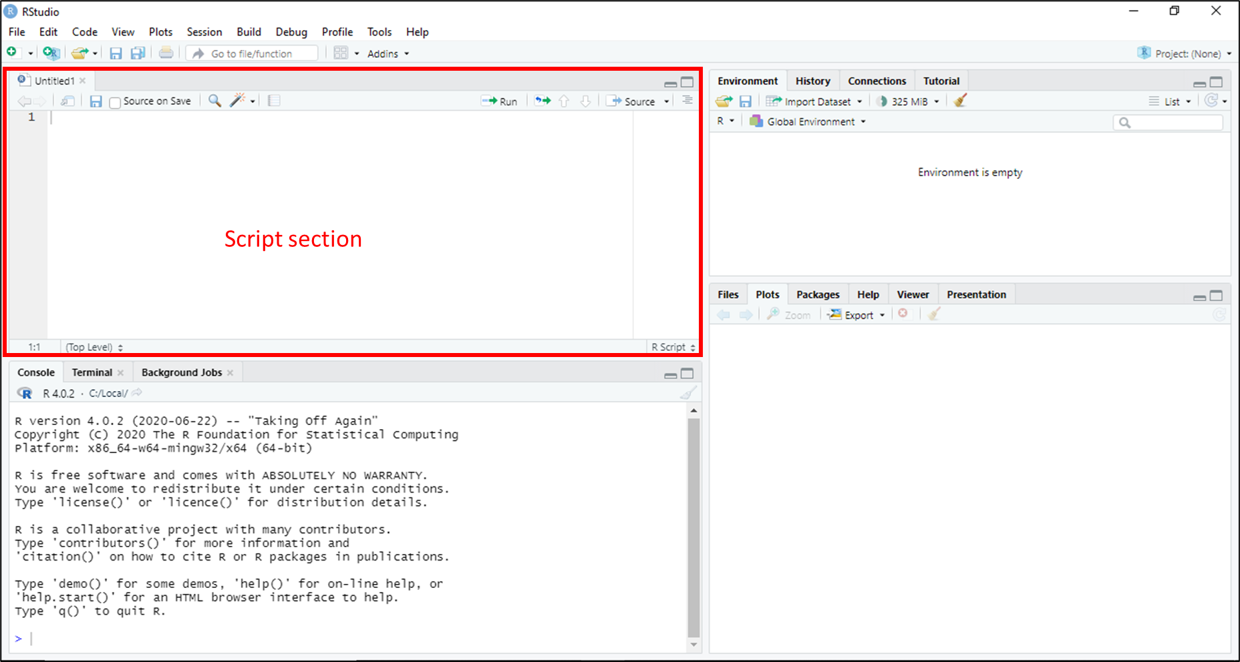

**Suggested reading:**

* UNFPA Technical Guidance Note: <https://www.unfpa.org/resources/value-modelled-population-estimates-census-planning-and-preparation>
* Research paper:
  + Wardrop et al (2018) Spatially disaggregated population estimates in the absence of national population and housing census data. <https://doi.org/10.1073/pnas.1715305115>
  + Boo et al (2022) High-resolution population estimation using household survey data and building footprints. <https://www.nature.com/articles/s41467-022-29094-x>
* STAN user manual: <https://mc-stan.org/users/documentation/>

**C++ compiler installation page**

<https://github.com/stan-dev/rstan/wiki/Configuring-C---Toolchain-for-Windows>